Profile HMM Report

Xinyuan Min. 950829573070

1. Read in the supplied small file test.fasta (example from “Biological Sequence Analysis”). What is the number of match states needed?



1. Train the HMM, i.e. the emission and transition probabilities. For emissions in the insert states, use the values supplied in pa. Print the estimated probabilities. Explain whether they make sense

*Emission probabilities:*



*Transition probabilities:*



*(The probabilities were rounded to 3 decimals for readability)*

1. Print the emission probability matrix in a format demanded by the SeqLogo server (http://www.cbs.dtu.dk/biotools/Seq2Logo-2.0/), e.g. the PSSM format (http://www.cbs.dtu.dk/biotools/Seq2Logo-2.0/bin/weight.txt), and use SeqLogo to generate a logo. Put both the matrix and logo in your answers.



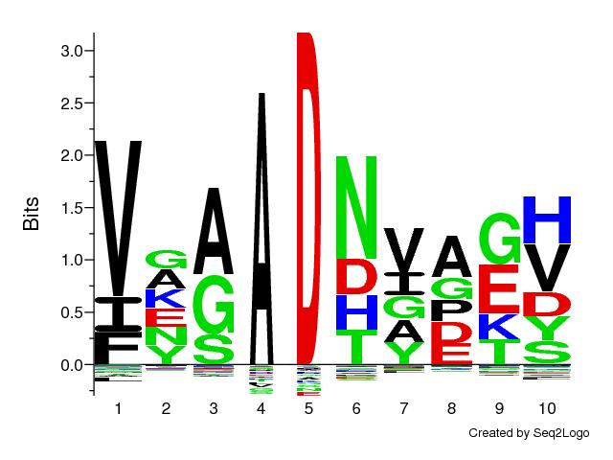

1. List at least 10 random sequences generated using your HMM



1. Change from using the estimated emission probabilities (EQ6.25) in your code to the background frequencies (EQ6.26) and repeat steps 2-4. How do the results change?



1. Read in the supplied large file test_large.fasta and repeat steps 2-5. Report the emission and transition probabilities, the logo (from SeqLogo), and the sampled sequences.

*Emission probabilities*





*Transition probabilities:*



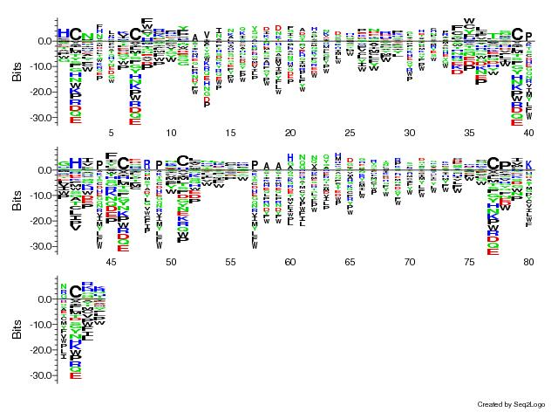

*Randomly generated sequence:*

**

1. Pick a randomly generated sequence and search for it in the PFAM database (http://pfam.xfam.org/). To what family does the sequence belong?

*I feel sorry that Pfam didn’t find the belonging family of my randomly generated sequence …*

1. What is the time complexity of estimating the emission and transition probabilities?

*The time complexity is O(n), as for each column, 2 count(amino acid + transition), (20+9) divisions are performed, and these operations are performed for n columns (n is the number of sequence)*

1. Which part of your code is deterministic and which part is randomized?

*Both the emission and transition probabilities are deterministic, the calculation obeys certain mathematical expression.*

*However, the sequence generation part is randomized, the transition between state and the amino acid at one position is randomly pick according certain probabilities distribution.*